Worsening LA-LB port congestion stalls recovery
Bill Mongelluzzo, Senior Editor | Feb 08, 2019 5:47PM EST
Print

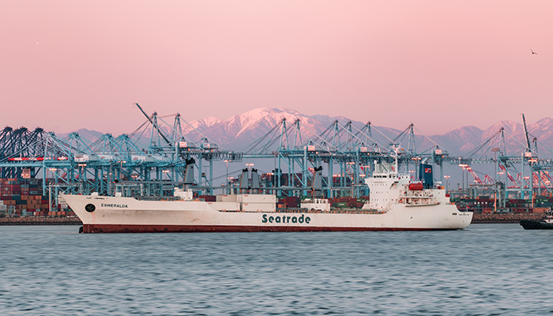
Imports in December increased 21.6 percent in Los Angeles and 7.9 percent in Long Beach, according to port statistics. Photo credit: Shutterstock.com.
Congestion at the Los Angeles-Long Beach port complex is worsening, having bled into intermodal rail operations and drayage to regional warehouses, pushing back expectations for relief to no sooner than March.
“We still remain in peak situation. We are expecting relief around the third week of February,” said Gene Seroka, executive director of the Port of Los Angeles. December was a big month for the ports, with imports increasing 21.6 percent in Los Angeles and 7.9 percent in Long Beach, according to port statistics.
Rather than dissipating with the onset of the Lunar New Year on Tuesday as anticipated, port sources are now projecting congestion will remain for about two more weeks. “Truckers, who are finding it increasingly difficult to secure appointments at the marine terminals and deliver inbound containers to severely impacted import distribution centers, are suffering collateral damage because of mounting storage charges. Known as demurrage, the charges for storing containers on the docks are assessed to beneficial cargo owners (BCOs), but if the BCOs delay in paying charges, truckers are shut out of the marine terminals, further compounding the congestion problem.

A persistent problem
The largest US port complex, which handles close to 40 percent of US imports, has struggled with congestion problems since last autumn due to a busy peak season for holiday merchandise, followed immediately by front-loading of imports as retailers and manufacturers attempted to get ahead of threatened 25 percent tariffs on more than $200 billion of imports from China. The more than 1.5 billion square feet of industrial real estate space in Southern California was over-subscribed because retailers delayed in shipping their spring merchandise to the eastern half of the country, causing inbound containers to back up at the ports. Making matters worse, an unusually large number of inbound containers and empties have been stored on chassis throughout the region, resulting in achassis shortage.
When container and chassis dwell times began to drop last month, the ports and terminals predicted congestion would dissipate in February and the harbor would return to fluidity later in the month. Now, the predictions do not look as rosy.
“From what I’ve heard, everyone thought it would be over sooner than this. It’s still pretty bad,” said Michael Klage, solutions director at TOC Logistics International. Even in some cases where containers have been cleared, truckers cannot take delivery of the inbound loads because they can’t secure enough chassis, he said.
“Nothing has changed,” said Scott Weiss, vice president of business development at Port Logistics Group. “We tell our customers, ‘We sent the trucks there, but the containers weren’t available.’” Weiss said it’s taking about 15 days on average for containers to move from the ports to inland destinations. Some outlier cases are in the four to five week range, he said.
A persistent problem since late last year has been at the import warehouses where spring merchandise is being held rather than being shipped inland. “They’re bringing in more volume than they’re shipping out,” Weiss said.
Chassis shortages and dislocations are contributing to the congestion at the marine terminals and warehouses. Hundreds of chassis are sitting under loaded import containers that can’t be unloaded at the warehouses. Hundreds more are stuck at trucker yards and warehouses with empty containers that marine terminals are refusing to accept because there is no space at the terminals for the empties.
The chassis dislocation problem, while bad for the past few weeks, has not gotten any worse, said Ron Joseph, executive vice president and chief operating officer of Direct ChassisLink, Inc. Currently there are about 26,000 chassis at the 12 container terminals and four intermodal rail yards in Southern California, the same as for the past six weeks, he said. Chassis street dwell time is also unchanged at about five days, he said.

Railroads compounding issues
The backlog of containers at the marine terminals because imports can't be drayed to distribution warehouses in a timely manner is now being compounded by service issues at the western railroads, BNSF and Union Pacific. The railroads are not departing trains on schedule, especially to secondary locations outside of the major hubs such as Chicago and Dallas Fort-Worth, so intermodal containers that should be moved from the marine terminals within 24 hours are sitting there for days.
"Union Pacific is still working through the surge of international intermodal volume into the West Coast late last year," said Raquel Espinoza, senior director of corporate communications and media relations. "We continue working with customers and others in the supply chain to move these shipments in a safe and efficient manner."
Lawrence Burns, senior vice president of trade and sales at HMM, said inbound intermodal containers are slow in being removed from the terminals, and the railroads in some cases are not taking export containers to the ports. The situation has reached the point where the railroads are placing the ocean carriers under allocations that fall short of their import and export volumes, he said. “It’s really been a struggle,” said Burns.
The rail problems in some cases began at inland locations due to weather issues this past month. BNSF for four days was not accepting containers at its Logistics Park Chicago, although the embargo was lifted earlier this week, said Kevin Krause, vice president of ocean services at SEKO Logistics. The rail problems have been somewhat random, Krause said, with some containers moving quickly from the marine terminals in Los Angeles-Long Beach while others are stuck in the bottom of container stacks for days or weeks. This situation has raised concerns about demurrage charges, he said. UP and BNSF weren’t available for immediate comment.
Harbor truckers in particular are feeling the impact of demurrage charges, even though the charges are made to the freight, not to the trucker. If the BCO does not promptly pay demurrage charges, the trucker pulling for that customer may be shut out of the terminal on future calls until the demurrage has been paid.
Also contributing to elevated demurrage storage charges and detention charges on equipment return is the increasing tendency of carriers operating in vessel-sharing alliances to receive the inbound container at one terminal and then direct the trucker to return the container when it is emptied to another terminal. Fred Johring, president of Golden State Logistics, said it often happens that the trucker is unable to make an appointment at the second terminal until after free time for return of the container, known as per diem, has expired. “We can’t terminate them, and to document this to dispute the per diem is a challenge,” Johring said.
The congested terminals are playing havoc with truckers’ ability to make sufficient round trips because drivers spend too much time in long lines. Average turn times in the port complex from October through December spiked to 90 minutes from less than 80 minutes for most of the year, according to the Harbor Trucking Association, but Johring said it is the exceptions that are causing the greatest problems with turn times. “We have quite a few that are well over two hours,” he said. “In the last 30 days, 9 percent of our visits were over three hours, 4 percent were over four hours, and 2 percent over five hours.”
Contact Bill Mongelluzzo at bill.mongelluzzo@ihsmarkit.com and follow him on Twitter: @billmongelluzzo.

